Title: Allow multiple viewing groups per drawing instruction

S-100 Maintenance - Change Proposal Form

|  |  |  |  |
| --- | --- | --- | --- |
| **Organisation** | NIWC | **Date** | 4/14/2021 |
| **Contact** | David Grant | **Email** | David.Grant1@navy.mil |

Change Proposal Type *(Select only one option)*

|  |  |  |
| --- | --- | --- |
| 1.Clarification | 2.Correction | 3.Extension |
|  |  | X |

Location (*Identify all change proposal locations)*

|  |  |  |  |
| --- | --- | --- | --- |
| S-100 Version No. | Part No. | Section No. | Proposal Summary |
| 5.0 20210330 draft | 9  9a | See attached  See attached | Multiple viewing groups per drawing instruction.  Multiple viewing groups per drawing command. |

Change Proposal

Update Part 9/9a to allow assignment of multiple viewing groups per drawing instruction.

Change Proposal Justification

Facilitates portrayal implementation of feature annotations, especially the S-52 “text group” concept. Causes annotations to toggle with the annotated feature by extending *DrawingInstruction* to allow multiple viewing groups; all viewing groups must be “on” to enable the drawing instruction.

Allows portrayal to emit text instructions with two (or more) viewing groups: a viewing group to toggle the text visibility, and a viewing group of the annotated feature/drawing instruction(s). The annotation is therefore only visible when the annotated feature is visible.

The concept also applies to symbol annotations, such as the S-101 date dependent and additional chart information (INFORM) symbols.

What parts of the S-100 Infrastructure will this proposal affect?

S-100 Feature Concept Dictionary Interface or Database

S-100 Portrayal Register

S-100 Feature Catalogue Builder

S-100 Portrayal Catalogue Builder

S-100 UML Models

S-100 GitHub Schemas

**Please send completed forms and supporting documentation to the secretary S-100WG.**

**Part 9**

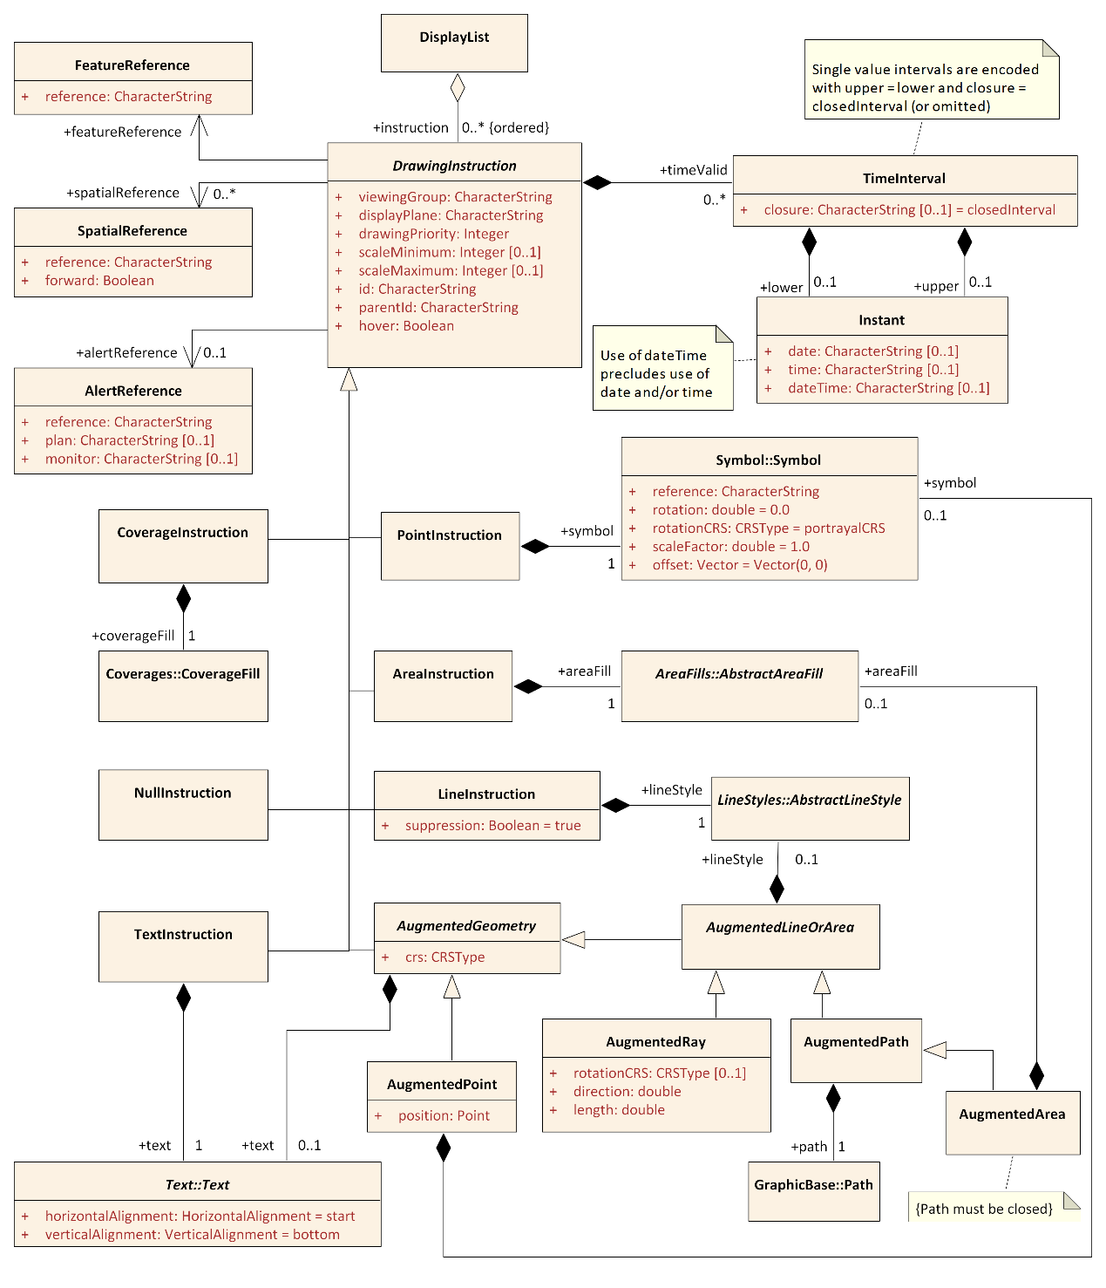

Figure 9-10 — Drawing Instructions

### Viewing Groups, Viewing Group Layers and Display Mode

The viewing group is a concept to control the content of the display. It works as an on/off switch for any drawing instruction assigned to the corresponding viewing group. The concept can be seen as a filter on the list of drawing instructions.

A drawing instruction which has multiple viewing groups is disabled when any assigned viewing group is disabled.

Viewing groups can be aggregated into Viewing Group Layers and Viewing Group Layer can be aggregated into Display Modes. Both aggregations are part of the portrayal catalogue.

### DrawingInstruction

| **Role Name** | **Name** | **Description** | **Mult.** | **Type** |
| --- | --- | --- | --- | --- |
| Class | DrawingInstruction | Abstract base class for all drawing instructions | - | - |
| Attribute | id | An identifier for the drawing instruction | 0..1 | string |
| Attribute | parentId | Instruction is dependent on a parent drawing instruction | 0..1 | string |
| Attribute | hover | Specifies whether the instruction is shown only on hover-over. OEM support for this feature is optional | 0..1 | boolean |
| Attribute | viewingGroup | The viewing group(s) the instruction is assigned to.Instruction is disabled if any viewing group is disabled. | 1..* | string |
| Attribute | displayPlane | The display plane the instruction is assigned to | 1 | string |
| Attribute | drawingPriority | The priority that defines the order of drawing | 1 | integer |
| Attribute | scaleMinimum | Scale denominator to define the minimum scale for which the instruction will be shown. If not given there is no minimum scale | 0..1 | integer |
| Attribute | scaleMaximum | Scale denominator to define the maximum scale for which the instruction will be shown. If not given there is no maximum scale | 0..1 | integer |
| Role | featureReference | The reference to the feature type that will be depicted by the instruction | 1 | FeatureReference |
| Role | spatialReference | The reference(s) to the spatial type components of the feature that defines the geometry used for the depiction. Not used when the entire geometry of the feature should be depicted | 0..* | SpatialReference |
| Role | timeValid | The drawing instruction is valid during the specified time interval(s) | 0..* | TimeInterval |
| Role | alertReference | The reference to the alert in the alert catalogue that is triggered by the geometry of the instruction | 0..1 | AlertReference |

Part 9a

Table 9a-3 – Drawing Commands

|  |  |  |  |
| --- | --- | --- | --- |
| **Command** | **Parameters** | **Parameter Type** | **Part 9 Reference** |
| ... | ... | ... | ... |
| TextInstruction | text | String | 9-11.2.10  9-11.2.12 |
|  |  |
|  |  |
| ... | ... | ... | ... |

**9a-11.2.1**

[…]

##### TextInstruction:*text*

Instructs the host to draw the specified text placed as follows:

Table 9a-5 – TextInstruction Initial Placement

|  |  |
| --- | --- |
| **Geometry Type** | **Initial Placement** |
| Point | Relative to the point |
| Line | Relative to the line as determined by *LinePlacement* |
| Area | Relative to *AreaCRS*. Note that this can cause the text to be drawn at multiple locations |

Once the initial positioning is determined, the text is offset as specified by state commands *LocalOffset* and *TextVerticalOffset*. The text is aligned as specified by state commands *TextAlignHorizontal* and *TextAlignVertical*.

If preceded by a *FontReference* command the font is as specified in the Portrayal Catalogue. Otherwise the host should construct a font using the values specified by preceding *FontColor, FontSize, FontProportion, FontWeight, FontSlant, FontSerifs* and *FontStrikethrough* state commands.

*text* The text to display.

**9a-11.2.2.1 Visibility Commands**

Visibility commands affect the visibility and drawing order of all subsequent drawing commands. They correspond to attributes of the Part 9 clause 9-11.2.2 *DrawingInstruction* class.

**Table 9a-7 – Visibility Commands**

|  |  |  |  |  |  |
| --- | --- | --- | --- | --- | --- |
| **Command** | **Parameters** | **Type** | **Initial State** | **Part 9** | **Notes** |
| ViewingGroup | viewingGroup | String[] | - | 9-11.1.3 | For example: 21000 |
| … |
| viewingGroupN |
| … | … | … | … | … | … |

**ViewingGroup:*viewingGroup[,viewingGroup2[,…]]***

Sets the viewing group(s) for drawing commands which follow. The drawing command is disabled if any viewing group is disabled.

**Applicability**: All drawing commands except *NullInstruction*